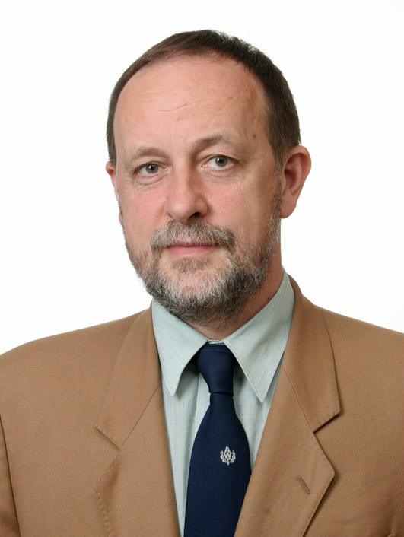
Dr hab. Michal Wychowański prof. Associate.
At the Academy of Physical Education since 1977. 1977/1978 military service. M.S. Ph.D. degrees in mechanical engineering received from the Warsaw University
of Technology. In years 2006 – 2014 head of Functional Diagnosis Center in Carolina Medical Center in Warsaw. 2010 dr hab. in physical education from Joseph Pilsudski Academy of Physical Education in Warsaw, thesis title: “Selected methods for assessing the dynamics of the human motor system”. Since 2012 head of Laboratory of Biomechanics at AWF Warsaw, Faculty of Rehabilitation. Two months 2000, scientific fellowship at University of Vienna in Hebert Hatze Laboratory of Biomechanics. Six months 2009, scientific fellowship at Institute
of Biocybernetics and Biomedical Engineering in Warsaw in Laboratory
of Mathematical Modelling led by professor Jacek Waniewski. Member of Polish Society of Biomechanics and Polish Society of Biomedical Engineeering.

Main research interests:
- Measurements physical features of human musculoskeletal system.
- Modeling and computer simulation of biomechanical systems.
- Modeling of musculoskeletal system of the human being
- Measurements and analysis of loads at the joints of the human being during specified athletic events
- Application of optimization techniques in biomechanics

Chapter in a monograph: Michał Wychowański, Arnold Baca: Rowing in:
Modelling and simulation in sport and exercise, ed. by Arnold Baca and Jürgen Perl
London, New York : Routledge, 2019

Inaugural lecture: “Methodology of mathematical modelling of the dynamics processes on the example of paddling sports"

